Release Notes

(Mapped Advisor, Automated Process Flow release notes)

1. **Introduction:**
2. Business Unit will be at the top of all departments which is mandatory for Member and Partner.
3. Each Department will be linked to a business unit. Departments will be of type PST, MST & FPA.
4. Departments will have team members as a child records. As departments get deleted, related team members will get deleted.
5. **Functionalities :**

**Lead**:

1. Whenever we create a **new Lead**, we need to specify following as a mandatory values :
2. Business Unit
3. Practice Owner
4. PST (Practice Success Team)
5. Biz Unit of Practice Owner should be same as that of Business unit selected for Lead.
6. Chatter post gets posted whenever there is any change in the
   1. Practice owner
   2. Biz unit
   3. PST (Practice Success Team) of any Lead.
7. When Lead is converted to the entity with the Lead Status “Converted”, the new Entity will have same business unit and Partner as that of Lead.
8. At the time of conversion of Lead to Member, Team Members of Practice Owner (Partner) will get populated in the Team Members of Member.

**Lead Team Member Allocation:**

1. Whenever new Lead is created and PST team member gets assigned to it, one record of Lead Team Member Allocation gets created which will be related list to the Team Member record as well as Lead Record.
2. On change of the Team Member assignment for the Lead, related list will get updated accordingly.
3. If Lead gets deleted, its corresponding Lead Team Member Allocation records will also be deleted.

**Partner:**

1. Whenever we create a **new partner**, we need to specify Business Unit and one member from each department (PST, MST, FPA).
2. Chatter post gets posted whenever there is any change in the team member assignment for any Member or partner.
3. Mail will be sent to the old Team Members User’s Manager accordingly and department heads, compliance and management and to the Partner itself if the Partners Team Members are changed. And if Members Team members are changed, then mail will be sent to the Members partner and to the department heads, compliance and management.
4. At the time of insert and whenever Team Member of Partner gets updated and, it’s Allocation By and Allocation dates get updated.
5. Whenever we change the PST, MST, FPA and MST2 of Partners then Pop up window comes if that PST, MST, FPA and MST2 is used previously in another Member.

Pop Up contains, Count of Client associated with that Team Member (Old). If there is not any change in PST, MST, FPA and MST2, popup will not be available.

**Member:**

1. Whenever we create a **new Member** (Entity), we need to specify Practice Owner (Partner) and Business Unit as a mandatory fields. Biz Unit of Practice Owner should be same as that of Business unit selected for member.
2. When new Member is created, Team Members (PST, MST, FPA, MST2) of Practice Owner will automatically get allocated to the current Member.
3. Whenever someone changes team member assignment of Member (Entity) manually, it will go through the Approval Process which will get trigger automatically.
4. If approval process gets approved, then the field will remain as it is changed. But if it gets rejected, then the original past value will get appear in the field.
5. Chatter post gets posted whenever there is any change in the team member assignment for any member.
6. If Members Team members are changed, then mail will be sent to the Members partner and the old Team Members User’s Manager accordingly and to the department heads, compliance and management.
7. Business unit selected for Partner should be same as Business unit of PST Team Member Business Unit. Same for MST, FPA and MST2.
8. At the time of insert and whenever Team Member of member gets updated and, it’s Allocation By and Allocation dates get updated.
9. If Practice Owner of any member is changed, Team members will get updated according to that Practice Owner.
10. If Any team member field is made blank and record is saved, then corresponding Practice Owner’s Team Member will get assign to that Member.

**Entity Team Member Allocation:**

1. Whenever new Partner/Member is created and team members get assigned to it, four records of EntityTeam Member Allocation get created which will be related list to the Team Member and Partner/Member record.
2. On change of the Team Member assignment for the Partner/Member, related list will get updated accordingly.
3. If Partner/Member gets deleted, its corresponding Entity Team Member Allocation records will also be deleted. Same, if Team Member is deleted, its corresponding EntityTeam Member Allocation records will be deleted.
4. In Team Member, **Entity Allocation Count** will get populated on the count of members (entities) which are having the same Team Member.
5. In Team Member, **Partner Allocation Count** will get populated on the count of partners which are having the same Team Member.
6. In Team Member, **Last Entity Allocation Date** will get populated depending on the last entity whose Team member has been modified recently.
7. **Data Model**

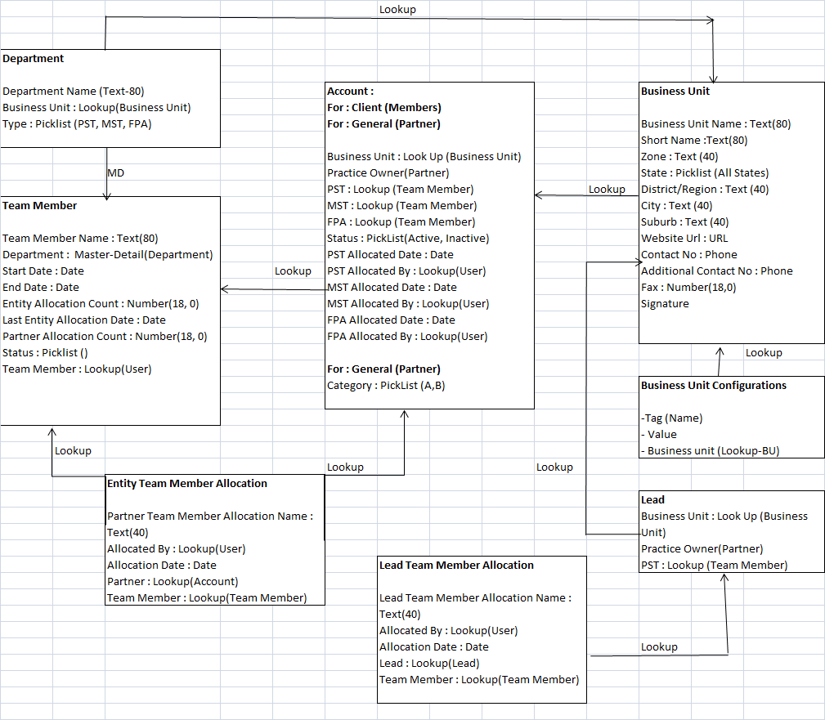

Automated Process Flow

# Introduction

“Automated MST Flow” functionality will be used to streamline the process of Member Success by assigning tasks to users based on current stage of the entity.

Automated Flows will start as soon as Entity gets created in SFDC and based on the status of Entity tasks will be created for corresponding users.

# Stages

## Entity Created (Meeting to get Entity Details whether interested in FP) –

Task Owner –MST 1

As soon as a new Entity is created a new task will be created for its corresponding MST 1 user to get Entity related details like whether it’s of type “Converted”, “Interested in FP” or “Not Interested in FP”.

Details for each status in SFDC–

1. Converted – Normal Automated Flows for the Entity will proceed. Once this task is completed, next task like “Perform Welcome Call for Member” will be created.
2. Interested in FP – For this status, a task will get updated to future date as meeting needs to be done again to decide on further steps on Entity.No further tasks will be created related to Automated flows.
3. Not Interested in FP – This task will get closed and no further tasks will be created for Automated Flows.

## Perform Welcome Call for Member

Task Owner – MST 1

After completion of first task, based on status, new task will be created for MST 1 to make a Welcome Call to Member. Due date will be Entity Creation + 2 days.

## Send Welcome Mail and SMS to Member

Task Owner – MST 1

After Welcome Call task is complete, this task will be created.

## Finalize Date for Data Collection of Member

Task Owner – MST 1

This task will be assigned to MST 1 of Member. While closing this task, user will need to enter Data Collection Date that will be used as Date for Data Collection for Member. This task needs to be completed before 7 days of Entity Creation.

## Confirm Date for Data Collection of Member

Task Owner – MST 1

The date finalized in previous task for Data Collection Date of Member will be used to decide due date for this task. This task will have due date as 1 day minus Data Collection date finalized by Member.

Here Task owner can either enter a new date or let the Data Collection date as it is. Possible options –

1. New Data Collection Date Entered – if task owner enters a new data collection date , then this task will have a new due date. It will be New Data Collection date entered minus 1 day.
2. If Same Data Collection Date then Flow will continue.

## Complete Data Collection

Task Owner – MST 1

This task will be assigned to MST 1 of Member to verify that Data Collection has been completed. Due date for this task will be Data Collection date finalized by user + 3 days.

## Complete Data Collection Approve

Task Owner – FPA

Once MST 1 of member has completed the task of Data Collection, a new task will be created for PFA of member to approve the data collection. While closing the task, FPA will select either Accept or Reject based on pick list value.

Based on Data Collection Approve Status selected, following can happen –

1. Accept – Then Automated MST flow will move to next task as per process.
2. Reject – If FPA rejects the Task, then he will need to enter comments while completing the task. If the task is rejected, then a new task will be created for MST 1 for Complete data collection and reject comments will be mentioned in the comments part of the Task, so that MST 1 will know the reason for rejection.

## Expected Financial Plan Completion Date

Task Owner – FPA

Once data collections have been approved, a new task will be created to complete expected Financial Plan Completion Date. Here user will need to enter expected date for Financial Plan generation before they can close this task.

## Parallel tasks creation

There will be three parallel tasks created after completion of Expected Financial Plan task .

### 9.1 Generate Financial Plan

Task Owner - FPA

User will need to Generate Financial Plan, and once they complete Generation of Financial Plan. Automated Flows will not restrict users from closing the task. But only be a mean to let user know of the next task that needs to be done.

### 9.2 Present and Approve FP Presentation to Partner

Task Owner – MST I

This will be second parallel task that will be created after completion of Expected Financial Plan task.

### 9.3 Finalize date for Financial Plan Presentation to Member

Task Owner – MST I

This will be the third task that will be created after completion of Expected Financial Plan task to finalize date for Financial Plan presentation to Member.

## Confirm date for Financial Plan Presentation to Member

Task Owner – MST I

New task will be created after completion of Date Finalization for Plan presentation to Member. User will have following options –

1. If new date for FP presentation have been entered and closed, then this same task will be updated with new FP presentation date of new date -1.
2. If same date is there and task gets closed, then flow will continue to next task.

## Present Financial Plan to Member

Task owner – MST I

New task will be created to Present Financial Plan to member. While closing this task, user will have two options –

1. Rework required – If there is any rework required on Financial Plan.
2. Rework not required – If all looks good and we can move ahead with the flow.

## Revise Financial Plan for Rework

Task owner – FPA

This task will be created if after FP presentation to Partner, rework is required.

## Get Financial Plan Approval from Member

Task owner – MST I

After FP has been finalized by Client, user will need to close this task after approval from Member.

## Get Action Plan

Task owner – FPA

New Task will be created to collect ‘Action Plan Sharing Date’ which will be populated on Entity detail Page with due date of Previous Task completion date + 5 days.

## Disseminate Action Plan to Member post Feedback from Partner

Task owner – FPA

New Task will be with due date of Previous Task completion date + 2 days.

## Activate Action Plan for Member

Task owner – MST I

New Task will be with due date of Previous Task completion date + 2 days.

## Open Execution Tracker

Task owner – MST I

New Task will be created with blank due dates.

## Close Execution Tracker

Task owner – MST II

New Task will be created with blank due dates.

Component Used in Mapping Advisory and Automated Flow

1. **Object**

|  |  |  |
| --- | --- | --- |
| **Name** | **Type** | **Comment** |
| Department | Custom object | New |
| Team Member | Custom object | New |
| Business Unit | Custom object | New |
| Partner Team Member Allocation | Custom object | New |
| Business Unit Configurations | Custom object | New |
| Account | Standard Object | Old |
| Lead | Standard Object | Old |
| Notification Queue | Custom object | New |
| Workflows Tracker Details | Custom object | New |
| Workflows Tracker Master | Custom object | New |
| Entity Team Member Allocation | Custom object | New |
| Lead Team Member Allocation | Custom object | New |
| 1. **Apex Class** |  |  |
| PathfinderLeadHandler | Apex Class | New |
| CreateProcessFlowTrackerHandler | Apex Class | New |
| WorkflowsTrackerDetailsHandler | Apex Class | New |
| TaskEscalationScheduler | Apex Class | New |
| TaskHandler | Apex Class | New |
| AccountApprovalSubmitHandler | Apex Class | New |
| BatchTaskEscalation | Apex Class | New |
| AccountLookUpCustomController | Apex Class | New |
| TeamMemberHandler | Apex Class | New |
| TeamMemberLookupController | Apex Class | New |
| NewEditAccountController | Apex Class | New |
| NewEditLeadController.cls | Apex Class | New |
| OnEntityOwnerChange | Apex Class | New |
| LeadLookupCustomController | Apex Class | New |
| LeadHandler | Apex Class | New |
| 1. **Visualforce Page** |  |  |
| AccountLookUpCustom | Visualforce Page | New |
| NewEditAccount | Visualforce Page | New |
| NewEditLead | Visualforce Page | New |
| TeamMemberLookup | Visualforce Page | New |
|  |  |  |
| 1. Field |  |  |
| MST Old Value For Approval | Account Field | New |
| PST Old Value For Approval | Account Field | New |
| FPA Old Value For Approval | Account Field | New |
| MST2 Old Value For Approval | Account Field | New |
| Rejected? | Account Field | New |
| MST Old Value | Account Field | New |
| PST Old Value | Account Field | New |
| FPA Old Value | Account Field | New |
| MST2 Old Value | Account Field | New |
| Entity_Intereseted_in_FP_Status__c | Account Field/ Task Field | New |
| DataCollectionDate__c | Account Field/ Task Field | New |
| Data Collection Completion Reject Reason | Account Field/ Task Field | New |
| ExpectedFinancialPlanGenerationDate__c | Account Field/ Task Field | New |
| FinancialPlanGenerationDate__c | Account Field/ Task Field | New |
| PartnerFinancialPlanPresentationDate__c | Account Field/ Task Field | New |
| MemberFinancialPlanPresentationDate__c | Account Field/ Task Field | New |
| Plan_Presentation_Completion_Status__c | Account Field/ Task Field | New |
| PlanGenerationDateFromSystem__c | Account Field/ Task Field | New |
| ActionPlanSharingDate__c | Account Field/ Task Field | New |
| Business_Unit__c | Account Field | New |
| PST_Team_Member__c | Account Field | New |
| MST_Team_Member__c | Account Field | New |
| FPA_Team_Member__c | Account Field | New |
| OPS_Team_Member__c | Account Field | New |
| Category__c | Account Field | New |
|  |  |  |
|  |  |  |
|  |  |  |
| **5)Workflow** |  |  |
|  |  |  |
| Team Member Name population | Team Member | Workflow |
|  |  |  |
| **6)Apex Trigger** |  |  |
| LeadTrigger | Apex Trigger | Old |
| WorkflowsTrackerDetailsTrigger | Apex Trigger | New |
| TaskTrigger | Apex Trigger | New |
| UpdateEntityOwner | Apex Trigger | New |
| AccountTrigger | Apex Trigger | Old |
| WellNessLeadTrigger | Apex Trigger | New |
| TeamMemberTrigger | Apex Trigger | New |
| **7) Test Class** |  |  |
| PathfinderLeadHandlerTest | Test Class | New |
| WorkflowsTrackerDetailsHandlerTest | Test Class | New |
| NewEditLeadControllerTest.cls | Test Class | New |
| NewEditAccountControllerTest | Test Class | New |
| TeamMemberLookupControllerTest.cls | Test Class | New |
| OnEntityOwnerChangeTest | Test Class | New |
| TeamMemberHandlerTest | Test Class | New |
| AccountLookupCustomControllerTest | Test Class | New |
| TaskHandlerTest | Test Class | New |
| BatchTaskEscalationTest | Test Class | New |
| LeadLookUpCustomControllerTest | Test Class | New |
| AccountApprovalSubmitHandlerTest | Test Class | New |
| **8)Validation Rule** |  |  |
| Business_Unit_Parnter_Same_for_MST2 | Account | New |
| Business_Unit_for_Parnter | Account | New |
| Business_Unit_for_PST | Lead | New |
| Business_Unit_should_be_same | Lead | New |
| **9)Custom Setting** |  |  |
| Automated Workflows CS | Custom Setting | New |
| **10) Record Type** |  |  |
| Automated Flows Master | Task | Record Type |
| Data Collection Completion | Task | Record Type |
| Data Collection Completion Approved | Task | Record Type |
| Data Collection Date Confirmation | Task | Record Type |
| Date For Plan Presentation | Task | Record Type |
| Master | Task | Record Type |
| Member Plan Presentation Confirmation | Task | Record Type |
| Partner Plan Presentation Date | Task | Record Type |
| Plan Presentation Completion | Task | Record Type |
| **11) Approval Process** |  |  |
| Team Member Allocation Change Approval | Account: | Approval Processes |